OLABISI ONABANJO UNIVERSITY
College of Engineering & Environmental Studies,
Faculty of Engineering
Ibogun Campus.
MECHANICAL ENGINEERING DEPARTMENT


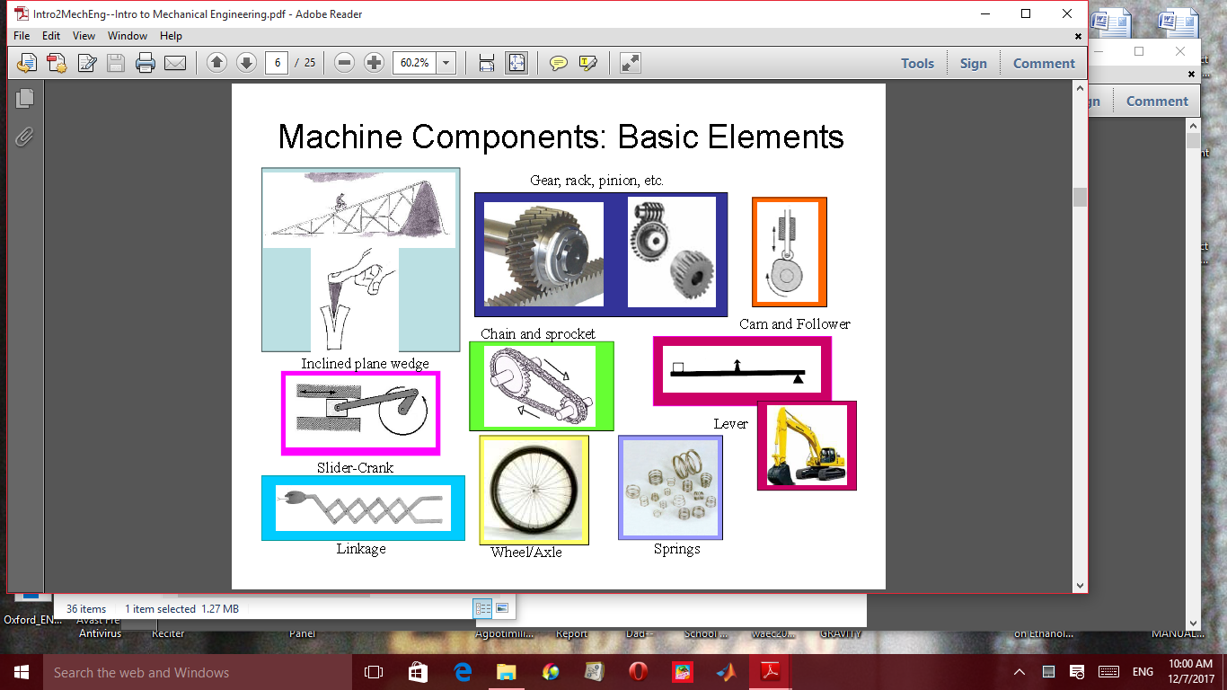 MECHANICS OF MACHINES II
LABORATORY MANUAL
MEG 302
300 LEVEL
NAMES…………………………………………………………………………………..
MATRIC. NO. :……………………………… LEVEL: ………………………………
DEPT.: ………………………………………. GROUP NO: …………………………
COURSE:……………………………………. CODE: ………………………………..
DATE:…………………SESSION:………………SIGNATURE…………………….

MECHANICS OF MACHINES PRACTICALS (MEG 302)

Table of contents
Experiment 1 Gear Characteristics Experiment
Experiment 2 Gear classification
Experiment 3 Gear Train Experiment
Experiment 4 Kinematics Links and Mechanisms
Experiment 5 Coefficient of friction between belt and pulley
Experiment 6 Proell Governor Experiment

CHAIN and GEAR DRIVES
Objectives
At the end of the study, the students should be able to
- Name the different types of belt and chain drives
- Explain what gear train, gear drives and gear boxes are
- Identify signs of wear on a belt or chain drive
- Apply the knowledge of drives and mechanical parts to remove, inspect and install a chain or a belt
- Explain the importance of lubrication.
Introduction
Power Transmission
Power transmission machines uses chains, gears or belts. Generally, chain is an economical part of power transmission machines for low speeds and large loads. However, it is also possible to use chain in high speed conditions like automobile engine camshaft drives. This is accomplished by devising a method of operation and lubrication.
Basically, there are lower limits of fatigue strength in the gear and the chain, but not in the belt. Furthermore, if a gear tooth breaks, the gear will stop at the next tooth. Therefore, the order is gear better than chain and chain better than belt in the aspect of reliability.
In most cases:
(1) An increase in gear noise indicates that the end of the service life is near.
(2) You will know that the chain is almost at the end of its life by wear elongation or an increase in vibration caused by wear elongation.
(3) It is difficult to detect toothed-belt life without stopping the machine and inspecting the belt carefully.
It is possible to decrease gear noise by adjusting the gears precisely or by adapting the drive to a helical or double helical gear. Both of these are expensive and thrust load may occur with the use of helical gears.
Chain is more suitable to long-term continuous running and power transmission with limited torque fluctuation. Gears are more fit to reversing or intermittent drives.
The greater the shaft center distance, the more practical the use of chain and belt, rather than gears.
Generally, under the same transmission conditions, the cost of toothed belts and pulleys is much higher than the cost of chains and sprockets.
See the following features and points of notice about roller chain transmission.
Features of Chain Drives:
1. Speed reduction/increase of up to seven to one can be easily accommodated.
2. Chain can accommodate long shaft-center distances (less than 4 m), and is more versatile.
3. It is possible to use chain with multiple shafts or drives with both sides of the chain.
4. Standardization of chains under the American National Standards Institute (ANSI), the International Standardization Organization (ISO), and the Japanese Industrial Standards (JIS) allow ease of selection.
5. It is easy to cut and connect chains.
6. The sprocket diameter for a chain system may be smaller than a belt pulley, while transmitting the same torque.
7. Sprockets are subject to less wear than gears because sprockets distribute the loading over their many teeth.
Points of Notice:
1. Chain has a speed variation, which is caused by the polygonal effect of the sprockets.
2. Chain needs lubrication.
3. Chain wears and elongates.
4. Chain is weak when subjected to loads from the side. It needs proper alignment.
If a substance, like grease or oil decreases the coefficient of friction, when it gets onto the belt contact surface, the belt cannot deliver the required tension.
Sprockets
(1) Tooth shapes are either ANSI- or BS-type. Currently the BS-type is used more frequently.
(2) Automotive engines are produced on a large scale. The sprockets for both the crankshaft and the camshaft are mass-produced from sintered metal.
Selection and Handling
(1) These chains are used with chain guides, levers, and tensioners to reduce chain elongation, vibration, and noise.
(2) Generally, the chains are selected according to the transmission torque, small-sprocket speed, and the layout. In mid- to high-speed transmission, vibration and lubrication must also be considered.
(3) These chains need forced lubrication.
Machines components – Basics elements

EXPERIMENT 1.
Title: Gear Characteristics Experiment
Objectives: at the end of the study, the student should be able to:
i. identify different types of gears
ii. know the gear applications
Equipment/Materials: Gear train apparatus, vernier caliper, micro meter crew gauge, steel rule
Theory : Gear transmits mechanical power through the meshing action of gears fixed on two closed shaft in equipment or machines. Gears can change both the direction and speed/velocity of a rotary motion and provide a very efficient way of transmitting power without slippage. Gear drive is appreciated for their reliability and service life; nevertheless its cost and lubrication required may limit their use.
The characteristics of gear primarily are: number of teeth, pitch diameter, circular pitch, diametrial pitch and pressure angle. NOTE, ONLY GEAR OF THE SAME DIAMETRIAL PITCH WILL MESH.
The two standard pressure angles are 20⁰ and 14.5⁰. Not; only gear gear with the same pressure angle will mesh. The line of action used in the definition of the pressure angle is the portion of the common tangent to the base cylinder along which contact between mating teeth occur.
Circular tooth thickness is the width of a tooth measured on the pitch circle. The gear characteristics are shown in the figure….. below.

Diagram
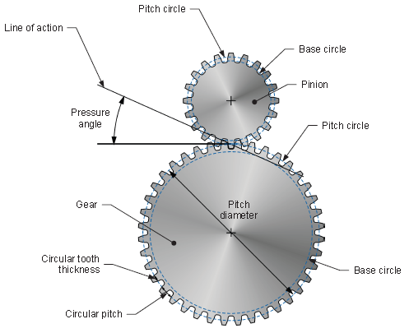
Figure 1.1: Gear characteristics

Procedure
i. Study the types of gear if figure……
ii. Note the differences in the two gears

Exercises
1. Count the number of gear teeth in figure 1.1 and record it in tabular form
2. Measure the tooth thickness of both gears
3. Measure the pitch circle diameter of both gears.
4. Measure the circular pitch of both gears.
5. State the differences between the two gears

PRACTICAL REPORT

EXPERIMENT: 1

Title:………………………………………………………………………………………………

Aims/Objectives:
………………………………………………………………………………………………….......................................................…..................................................................................................................................................................……………………………………………………………………………………………………........................................................................................................................................................................................................................……………………………

Equipment/Apparatus/Materials:
………………………………………………………………………………………………………………………………………………………………………………………………………………………………………………………………………………………………………………

Theory:
………………………………………………………………………………………………….......................................................…..................................................................................................................................................................……………………………………………………………………………………………………........................................................................................................................................................................................................................……………………………
………………………………………………………………………………………………….......................................................…..................................................................................................................................................................……………………………………………………………………………………………………........................................................................................................................................................................................................................……………………………
………………………………………………………………………………………………….......................................................…..................................................................................................................................................................……………………………………………………………………………………………………........................................................................................................................................................................................................................……………………………
………………………………………………………………………………………………….......................................................…..................................................................................................................................................................……………………………………………………………………………………………………........................................................................................................................................................................................................................……………………………
………………………………………………………………………………………………….......................................................…..................................................................................................................................................................……………………………………………………………………………………………………........................................................................................................................................................................................................................……………………………
………………………………………………………………………………………………….......................................................…..................................................................................................................................................................……………………………………………………………………………………………………........................................................................................................................................................................................................................……………………………
….……………………………………………………………………………………………………………………………………………………………………………………………………………………………………………………………………………………………………………...
Diagram(s):

1. Count the number of gear teeth in figure 3.1 and record it in tabular form
........................................................................................................................................................................
.................................................................................................................................................................................................................................................................................................................................................................................................................................................................................................

2. Measure the tooth thickness of both gears
........................................................................................................................................................................................................................................................................................................................................................................................................................................................................................................................
........................................................................................................................................................................
3. Measure the pitch circle diameter of both gears.
................................................................................................................................................................................................................................................................................................................................................
................................................................................................................................................................................................................................................................................................................................................
4. Measure the circular pitch of both gears.
………………………………………………………………………………………........................................................................................................................................................................................................................……………………………
………………………………………………………………………………………………….......................................................…..................................................................................................................................................................……………………………………………………………………………………………………........................................................................................................................................................................................................................……………………………
5. State the differences between the two gears
………………………………………………………………………………………………….......................................................…..................................................................................................................................................................……………………………………………………………………………………………………........................................................................................................................................................................................................................……………………………
………………………………………………………………………………………………….......................................................…..................................................................................................................................................................…………….………………………………………………………………………………………........................................................................................................................................................................................................................……………………………
h. Precaution(s):
………………………………………………………………………………………………….......................................................…..................................................................................................................................................................……………
Reference(s):
……………………………………………………………………………………………………………………………………………………………………………………………………………………………………………………………………………………………………………………………………………………………………………………………………………………………………….......................................................…........
EXPERIMENT 2
Title: Gear classification
Objectives: the student should be able to:
a. identify different types of gears
b. know the gear applications
Equipment/Materials: Gear of different types, vernier caliper, micrometer screw gauge, ruler/steel rule.
Theory: Gear transmits mechanical power through the meshing action of gears fixed on two closed shaft in equipment or machines. Gears can change both the direction and speed/velocity of a rotary motion and provide a very efficient way of transmitting power without slippage. Gear drive is appreciated for their reliability and service life; nevertheless its cost and lubrication required may limit their use.
Gear is more efficient than chains and belts in mechanical power transmission.
Diagram
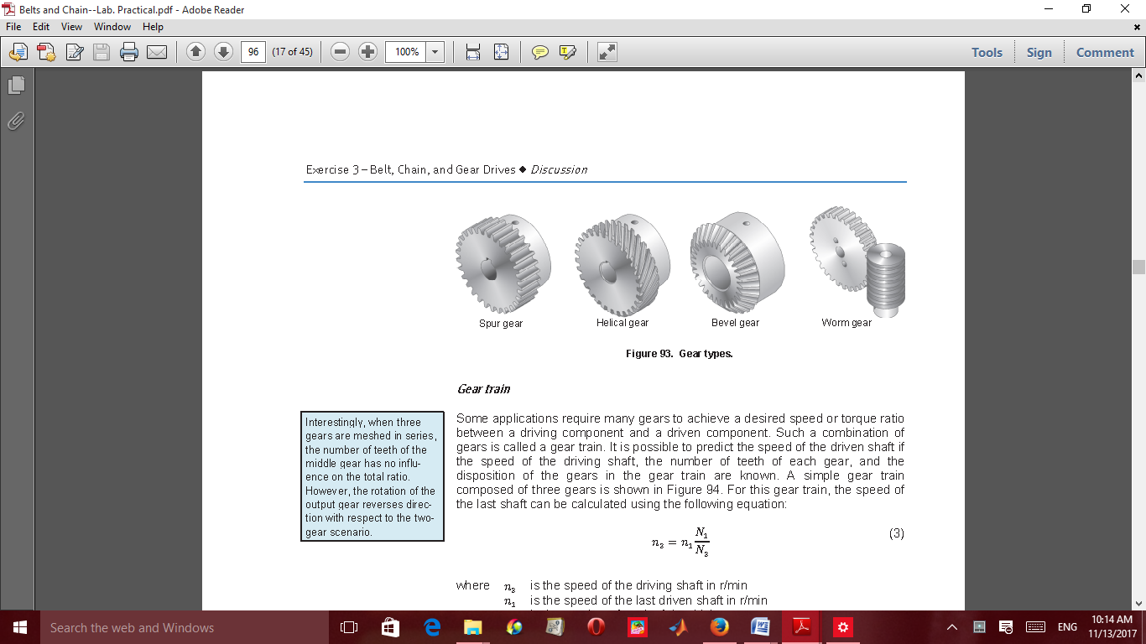
gear A gear B gear C gear D
Figure 2.1: Types of gears
Procedure
a. Study the gear arranged in figure 2.1
b. Note the differences in the gear studied
Exercises
1. Identify the four gears in figure 2.1A-D
2. Sketch the gears mentioned in Q1
3. State the applications of the gears mentioned in Q1
4. How would you reduce friction in gear when in motion?
5. What is the major advantage of gear compared with chains and belts?
6. State the precautions to be observed in gear drives.
PRACTICAL REPORT

EXPERIMENT: 2

Title:………………………………………………………………………………………………

Aims/Objectives:
………………………………………………………………………………………………….......................................................…..................................................................................................................................................................……………………………………………………………………………………………………........................................................................................................................................................................................................................……………………………

Equipment/Apparatus/Materials:
………………………………………………………………………………………………………………………………………………………………………………………………………………………………………………………………………………………………………………
Theory:
………………………………………………………………………………………………….......................................................…..................................................................................................................................................................……………………………………………………………………………………………………........................................................................................................................................................................................................................……………………………
………………………………………………………………………………………………….......................................................…..................................................................................................................................................................……………………………………………………………………………………………………........................................................................................................................................................................................................................……………………………
………………………………………………………………………………………………….......................................................…..................................................................................................................................................................……………………………………………………………………………………………………........................................................................................................................................................................................................................……………………………
………………………………………………………………………………………………….......................................................…..................................................................................................................................................................……………………………………………………………………………………………………........................................................................................................................................................................................................................……………………………
………………………………………………………………………………………………….......................................................…..................................................................................................................................................................……………………………………………………………………………………………………........................................................................................................................................................................................................................……………………………
………………………………………………………………………………………………….......................................................…..................................................................................................................................................................……………………………………………………………………………………………………........................................................................................................................................................................................................................……………………………
……………………………………………………………………………………………………………………………………………………………………………………………………………………………………………………………………………………………………………................................................................................................................................................................
Diagram(s):

1. Identify the four gears in figure 2.1A-D
………………………………………………………………………………………………….......................................................…..................................................................................................................................................................…………….………………………………………………………………………………………........................................................................................................................................................................................................................……………………………

2. Sketch the gears mentioned in Q1

3. State the applications of the gears mentioned in Q1
................................................................................................................................................................................................................................................................................................................................................
........................................................................................................................................................................................................................................................................................................................................................................................................................................................................................................................
.................................................................................................................................................................................................................................................................................................................................................................................................................................................................................................
4. How would you reduce friction in gear when in motion?
………………………………………………………………………………………........................................................................................................................................................................................................................……………………………
………………………………………………………………………………………………….......................................................…..................................................................................................................................................................……………………………………………………………………………………………………........................................................................................................................................................................................................................……………………………
………………………………………………………………………………………………….......................................................…..................................................................................................................................................................……………………………………………………………………………………………………........................................................................................................................................................................................................................……………………………
5. What is the major advantage of gear compared with chains and belts?
………………………………………………………………………………………………….......................................................…..................................................................................................................................................................……………………………………………………………………………………………………........................................................................................................................................................................................................................……………………………
………………………………………………………………………………………………….......................................................…..................................................................................................................................................................……………………………………………………………………………………………………..............................................................................
6. Precautions to be observed in gear drives.
........................................................................................................................................................................................................................................................................................................................................................................................................................................................................................................................
........................................................................................................................................................................
………………………………………………………………………………………………….......................................................…..................................................................................................................................................................……………………………………………………………………………………………………........................................................................................................................................................................................................................……………………………
Reference(s):
……………………………………………………………………………………………………………………………………………………………………………………………………………………………………………………………………………………………………………………………………………………………………………………………………………………………………….......................................................…..................................................................................................................................................................……………
EXPERIMENT 3
Title: Gear Train Experiment
Objectives: at the end of the study, the student should be able to:
a. Differentiate between gear train and gear boxes
b. Calculate any gear parameters
c. understand the speed ratios and directions of rotation of simple and compound gear trains.
Equipment/Materials: Gear train apparatus, vernier caliper, micro meter screw gauge, steel rule
Theory: Gear train is system that required more than two gears to archive a desired speed or torque. Some equipment and machines may require more than many gears to archives a desired speed or torque ratio between a driving components and a driven component.
The speed of the driven shaft can be predicted if the speed of the driving shaft, the number of teeth of each gear and the disposition of the gears in the gear train are known. The simple gear train example is shown in the figure 5.1 below. The speed of the last shaft can be calculated by using this equation: $n3 = n1(\frac{N1}{N3})$
Where n₃ = the speed of the driving shaft in rpm
n₁ = the speed of the last driven shaft in rpm
N₁ = the number of the teeth of the driving gear
N₃ = the number of the teeth of the last driven gear
Gear box is a gear train enclosed in housing. The example of gear train in a box is four gears of different sizes which can be used to modify the speed and torque ratio in two stages in a gear box.
When two meshed gears are involved (one gear stage), the ratio of gear teeth between the gears can be used to derive the rotational speed, torque, and gear ratio.
The following equation shows how the parameters are related: $R =\left(\frac{N2}{N1}\right)=\left(\frac{n1}{n2}\right)=(\frac{T2}{T1})$
Where R = the gear ratio
N1 = the number of teeth of the driving gear
N2 = the number of teeth of the driven gear
n1 = the speed of the driving gear in rpm
n2 = the speed of the driven gear inrpm
T1 = the torque of the driving gear in Nm
T2 = the torque of the driven gear in Nm
Note: The parameters can be rearranged to determine any of the parameter required.
If the torque of the of the driving gear needs to be determine, this relationship can be applied thus, $T1 = T2 (n2/n1) or T1 = T2 (N1/N2)$
Note: When the multiple stages of reduction are used, the total gear ratio is obtained by multiplying the individual ratios of each reduction stage by the other.
The module is the Pitch Circle Diameter divided by the number of teeth.
Diagram
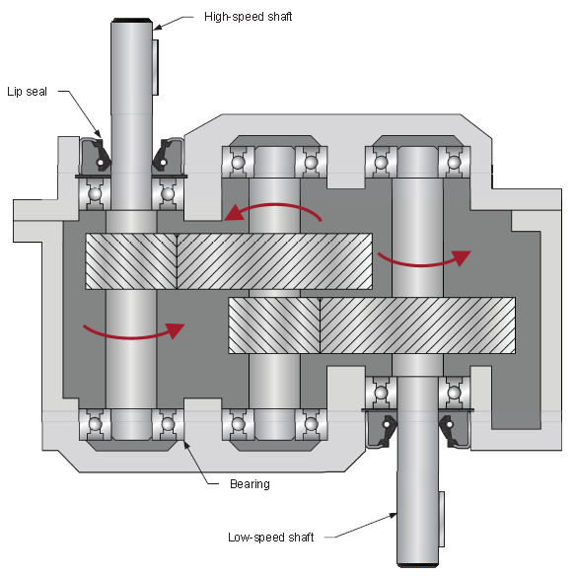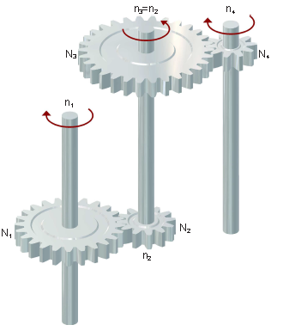
Figure 3.1: Gear box Figure 3.2: Two stages of gear reduction

$$1 2 3$$
$$Figure 3.3: Gear Train$$
Procedure
a. Study gears in figures 5.1 – 3.3
b. Inspect the gears train in figure 3.3.
c. Measurements of the pitch circle diameter of gears in figure 3.3
d. Count the number of teeth for each gear in figure 3.3.
Table 3.1: Gear measurements
Gear | Diameter (mm) | No of teeth | Module (mm)
1
2
3

Exercises
1. Determine the module of the gear system. Record your results in tabular form.
2. State the difference between the gear train and gear boxes
3. Calculate the speed of the last driven shaft if the number of teeth of the driving 50 and that of driven is 62, while the driving speed is 280rpm.
4. Calculate the number of driven teeth if its speed is 450rpm, the number of the driven teeth is 80 and that of driving is 120.
5. An electric pump motor drives a system comprising two gears and shafts in parallel with the driven gear has 75 teeth, the driving gear has 120 teeth and the driven shaft rotates at 90rpm. Calculate the driving shaft speed. Also, use the same values of gear teeth to determine the driven torque required if the driving torque is 12Nm. Hints: $n1 = n2\left(\frac{N2}{N1}\right), T2 = T1\left(\frac{N2}{N1}\right),$

PRACTICAL REPORT

EXPERIMENT: 3

Title:………………………………………………………………………………………………

Aims/Objectives:
………………………………………………………………………………………………….......................................................…..................................................................................................................................................................……………………………………………………………………………………………………........................................................................................................................................................................................................................……………………………

Equipment/Apparatus/Materials:
………………………………………………………………………………………………………………………………………………………………………………………………………………………………………………………………………………………………………………

Theory:
………………………………………………………………………………………………….......................................................…..................................................................................................................................................................……………………………………………………………………………………………………........................................................................................................................................................................................................................……………………………
………………………………………………………………………………………………….......................................................…..................................................................................................................................................................……………………………………………………………………………………………………........................................................................................................................................................................................................................……………………………
………………………………………………………………………………………………….......................................................…..................................................................................................................................................................……………………………………………………………………………………………………........................................................................................................................................................................................................................……………………………
………………………………………………………………………………………………….......................................................…..................................................................................................................................................................……………………………………………………………………………………………………........................................................................................................................................................................................................................……………………………
………………………………………………………………………………………………….......................................................…..................................................................................................................................................................……………………………………………………………………………………………………........................................................................................................................................................................................................................……………………………
………………………………………………………………………………………………….......................................................…..................................................................................................................................................................……………………………………………………………………………………………………........................................................................................................................................................................................................................……………………………
……………………………………………………………………………………………………

Diagram(s):

1. Determine the module of the gear system. Record your results in tabular form.
Gear | Diameter (mm) | No of teeth | Module (mm)
1
2
3

2. State the difference between the gear train and gear boxes
………………………………………………………………………………………………….......................................................…..................................................................................................................................................................…………….………………………………………………………………………………………........................................................................................................................................................................................................................……………………………

3. Calculate the speed of the last driven shaft if the number of teeth of the driving 50 and that of driven is 62, while the driving speed is 280rpm.
........................................................................................................................................................................................................................................................................................................................................................................................................................................................................................................................
........................................................................................................................................................................

4. Calculate the number of driven teeth if its speed is 450rpm, the number of the driven teeth is 80 and that of driving is 120.
................................................................................................................................................................................................................................................................................................................................................
........................................................................................................................................................................................................................................................................................................................................................................................................................................................................................................................
………………………………………………………………………………………........................................................................................................................................................................................................................……………………………
………………………………………………………………………………………………….......................................................…..................................................................................................................................................................……………………………………………………………………………………………………...............................................................................................................................................................................................................................................................................................................................................................................................................................................................................................................................................................……………………………
………………………………………………………………………………………………….......................................................…..................................................................................................................................................................……………………………………………………………………………………………………........................................................................................................................................................................................................................……………………………
..........................................................................................................................................................

5. An electric pump motor drives a system comprising two gears and shafts in parallel with the driven gear has 75 teeth, the driving gear has 120 teeth and the driven shaft rotates at 90rpm. Calculate the driving shaft speed. Also, use the same values of gear teeth to determine the driven torque required if the driving torque is 12Nm. Hints: $n1 = n2\left(\frac{N2}{N1}\right), T2 = T1\left(\frac{N2}{N1}\right),$
………………………………………………………………………………………........................................................................................................................................................................................................................……………………………
………………………………………………………………………………………………….......................................................…..................................................................................................................................................................……………………………………………………………………………………………………...............................................................................................................................................................................................................................................................................................................................................................................................................................................................................................................................................................……………………………
………………………………………………………………………………………………….......................................................…..................................................................................................................................................................……………………………………………………………………………………………………........................................................................................................................................................................................................................……………………………
………………………………………………………………………………………........................................................................................................................................................................................................................……………………………
………………………………………………………………………………………………….......................................................…..................................................................................................................................................................……………………………………………………………………………………………………...............................................................................................................................................................................................................................................................................................................................................................................................................................................................................................................................................................……………………………
………………………………………………………………………………………………….......................................................…..................................................................................................................................................................……………………………………………………………………………………………………........................................................................................................................................................................................................................……………………………
6. Precaution(s):
………………………………………………………………………………………………….......................................................…..................................................................................................................................................................……………………………………………………………………………………………………........................................................................................................................................................................................................................……………………………
………………………………………………………………………………………………….......................................................…..................................................................................................................................................................……………………………………………………………………………………………………..............................................................................
Reference(s):
……………………………………………………………………………………………………………………………………………………………………………………………………………………………………………………………………………………………………………………………………………………………………………………………………………………………………….......................................................…........................................................................

EXPERIMENT 4

Title:- Kinematics links and mechanics

Objective: - To study various types of kinematics links, pairs, chains and mechanisms.

Apparatus: - Kinematics links, pairs, chains and mechanisms.

Theory: -
1. Definitions of kinematics links, pairs, chains and mechanisms.
- Classifications of kinematics links, pairs, chains and mechanisms.
- Diagrams of kinematics links, pairs, chains and mechanisms.
4. Advantages and disadvantages of kinematics links, pairs, chains and mechanisms.
5. Applications of kinematics link, Pairs, chains and mechanism.
6. Examples of kinematics link, Pairs, chains and mechanisms.

Figure 4.1: Slider Crank Mechanics
KINEMATIC LINK: - A mechanism is made of a number of resistant bodies out of which some may have motions relative to the others. A resistant body or a group of resistant bodies with rigid connections preventing their relative movement is known as a link. A link is also known as kinematic link or element.

Examples:- A slider-crank mechanism consists of four links: frame and guides, crank connecting rod and slider, the crank link may have crankshaft and flywheel also, forming one link having no relative motion of these.

CLASSIFICATIONS OF LINKS:-
1. Binary link
2. Ternary link
3. Quarternary link

KINEMATIC PAIR:- A kinematic pair or simply a pair is a joint of two links having relative motion between them.

CLASSIFICATIONS OF PAIRS:
1. Kinematics pairs according to nature of contact:
(i) Lower pair (links having surface or area contact)
Examples:- Nut turning on a screw, shaft rotating in a bearing, universal joint etc.
(ii) Higher pair (Point or line contact between the links)
Examples:- when rolling on a surface, cam and follower pair, tooth gears, ball and roller bearings etc.
2. Kinematics pairs according to nature of Mechanical Constraint:
(i) Closed pair (when the elements of a pair are held together mechanically)
Examples:- all the lower pairs and some of the higher pair
(ii) Unclosed pair (when two links of a pair are in contact either due to force of gravity or some spring action),
Example:- cam and follower pair.

3. Kinematics pairs according to nature of relative motion:-
(i) Sliding pair
(ii) Turning pair
(iii) Rolling Pair
(iv) Screw pair (Helical pair)
(v) Spherical pair

KINEMATIC CHAIN:- A kinematic chain is an assembly of links in which the relative motions of the links is possible and the motion of each relative to the others is definite. If indefinite motions of other links, it is a non-kinematic chain.
Kinematic chains turn into a mechanism when one of the links in the chain becomes a frame. Kinematic inversion is the process of choosing different links in the chain as frames.
Types of kinematics chains:-
(i) Four bar chain or quadric cycle chain
(ii) Single slider crank chain
(iii) Double slider crank chain

MECHANISM:- A linkage is obtained if one of the links of a kinematics chain is fixed to the ground. If motion of each link results in definite motions of the others, the linkage is known as a mechanism. If one of the links of a redundant chain is fixed, it is known as a structure. The degree of freedom of a structure is zero or less. A structure with negative degree of freedom is known as a superstructure.
Mechanism is the linkage that has the motion of each link which results in definite motions of the others.
Exercises:
1. What is the difference between a linkage and a mechanism?
2. What is the difference between a mechanism and a structure?
3. Describe the following terms:
(a) kinematic inversion, (b) kinematic pair, (c) kinematic link, (d) kinematic chain
3. State three types of links observed in the mechanism.
4. Assume that a linkage has N DOF. If one of the links is made a frame, how will it affect the number of DOF of the mechanism?

EXPERIMENT 5

Title: Coefficient of friction between belt and pulley
Objective: To find coefficient of friction between belt and pulley.
Apparatus: Belt and Pulley System.
Theory:
1. Definition of belt and pulley.
- Diagram of belt and pulley system.
- To prove the relation of belt tension for flat belt.
T₁/ T₂ = ℮^{µθ}
Belt
Power is transmitted from one to another by means of belts.
- Belts are used where the distance between the shafts is large.
- Belts are flexible type of connectors.
- The flexibility of belts and ropes is due to the property of their materials.
- Belts transmit power due to friction between them and the pulleys. If the power transmitted exceeds the force of friction, the belt slips over the pulley.
- Belts are strained during motion as tensions are developed in them.
- Owing to slipping and straining action, belts are not positive type of drives.
Types of belts
- Flat belt
- V-belt
Material for belts: Materials used are leather, canvas, cotton and rubber.
Pulley
Pulley is mounted on the two shafts. The speed of the driven shaft can be varied by varying the diameters of the pulleys.
Types of pulleys
- Idler pulleys
- Intermediate pulleys
- Loose and fast pulleys
- Guide pulleys
FORMULAE USED T₁/ T₂ = ℮^{µ θ};
Where; T₁ = Tension at the tight side of the belt (N/m²)
T₂ = Tension at the slack side of the belt (N/m²)
µ = Co-efficient of Friction between belt and pulley θ = Arc of contact (radians)

Table 5.1: Table of values
S/N | T¹ (N/m²) | T₂ (N/m²) | Θ  (degree) (in radians) | µ = (1/θ) log (T₁/ T₂)

Calculation:- Co-efficient of Friction between belt and pulley (µ) = (1/θ) log (T₁/ T₂)
Procedure
a. Note the angle of arc of contact.
b. Hang some weight on one side of the belt and put some weight on other side of the belt, till the belt just slide
c. Note down the values of T₁ & T₂
d. Vary T₁ and correspondingly determine the value of T_{2 .}
Precautions
1. Tapping of pulley should be done after increasing the weight.
2. Weight should be increased in small step.
3. Add weights slowly without jerks.
Exercises
- Record the values of T₁ and T₂ in tabular form.
- Calculate the values of Co-efficient of Friction between belt and pulley (µ).

EXPERIMENT 6
TITLE: Proell Governor Experiment
AIM: Comparison of theoretical controlling force and experimental results of Proell Governor.
APPARATUS: TM 127 Governor Apparatus, Proell Governor, Electrical Tachometer,
Speed Control Unit.
THEORY:
F = Controlling Force (N)
M = Mass of the sleeve (kg)
m = mass of the ball (kg)
g = Acceleration due to gravity (m/s²)
ω = Angular speed in radian/sec
Taking moments about O.
F_{y} = mg(x – r ) + ½ Mg (x – b) ----------------------------------- (1)
Also if the shaft speed is steady, F is given by
F = mrω² ------------------------------------ (2)
An expression for ω as a function of y can be found by combining equations (1) and (2), Hence, ω² = g/ry[(x – r ) + M/2m(x – b )] ------------------------------- (3)
PROCEDURE:
a. Remove the Perspex dome and screw the governor to the turntable.
- Check that the screws are screwed down fully and that the drive belt is correctly located in the grooves. Replace the dome.
- Construct a table of shaft speed (rev/min) against sleeve between zero and 24mm, in steps of 4mm. Allow two columns for speed readings – one headed “Sleeve rising” the other “Sleeve falling”.
d. Set the E64 MKII range selector to 300. Start the motor by turning the speed control and slowly increase the speed until the sleeve just begins to lift. Note the tachometer reading.
e. Slowly increase the motor speed until the sleeve rises to the first mark on the shaft. This is 4mm from the base. Note the tachometer reading. (see note below).
f. Repeat step 4 for each successive mark on the shaft. Alter the E64 MKII range if the reading goes off the scale.
g. When the sleeve is at it’s highest position, decrease the motor speed until the sleeve just begins to fall. Note the tachometer reading (sleeve falling).
h. Slow down the motor until the sleeve reaches the next highest mark and note the tachometer reading. If you should overshoot the mark, increase the speed until the sleeve rises above the mark then approach the mark again from above.
i. Repeat step (g) until the sleeve has reached the base.
j. Read the governor speed corresponding to each sleeve height.
(NOTE: IF THE SLEEVE RISES ABOVE THE MARK YOU ARE AIMING FOR, DO NOT DECREASE THE SPEED SO THAT THE SLEEVE REACHES THE MARK FROM ABOVE. THIS WILL GIVE A FALSE READING DUE TO FRICTION BETWEEN THE SLEEVE AND THE SHAFT. INSTEAD, DECREASE THE SPEED UNTIL THE SLEEVE FALLS BELOW THE APPROPRIATE MARK. THEN INCREASE THE MOTOR SPEED UNTIL THE SLEEVE REACHES THE MARK FROM BELOW)
Tabulate your results as follow:
Table 6.1: Table of values
Sleeve lift (x) (mm) | Governor speed  (rad/sec) | Controlling force**  (N)
0
4
8
12
16
20
24

Exercises
**Using equation
(i) determine the values of F corresponding to each speed of governor recorded from electrical tachometer.
- Measurement x,y, and r have to be found for a range of sleeve lift, x_{i} either by calculation or drawing. (Hint: if doing this by calculation, start by calculating the angles α, β, γ for range of values of r_{p})
- Calculate ω from equation (3) for each sleeve displacement.
- Calculate F from equation (2) for each sleeve displacement
- Tabulate your results
- Using the same axes plot the graph of controlling force both (theoretical and experimental results) against sleeve rise.
- Compare the two graphs.

NOTES:
.........................................................................................................................................................……………………………………………………………………………………………………........................................................................................................................................................................................................................……………………………
………………………………………………………………………………………………….......................................................…..................................................................................................................................................................……………………………………………………………………………………………………........................................................................................................................................................................................................................……………………………
…………………………………………………………………………………………………………………………………………………………………………………………………………………………………………………………………………………………………………….......………………………………………………………………………………………………….......................................................…..................................................................................................................................................................……………………………………………………………………………………………………........................................................................................................................................................................................................................……………………………
………………………………………………………………………………………………….......................................................…..................................................................................................................................................................……………………………………………………………………………………………………........................................................................................................................................................................................................................……………………………
………………………………………………………………………………………………….......................................................…..................................................................................................................................................................……………………………………………………………………………………………………........................................................................................................................................................................................................................……………………………
………………………………………………………………………………………………….......................................................…..................................................................................................................................................................……………………………………………………………………………………………………........................................................................................................................................................................................................................……………………………
………………………………………………………………………………………………….......................................................…..................................................................................................................................................................……………………………………………………………………………………………………........................................................................................................................................................................................................................……………………………
………………………………………………………………………………………………….......................................................…..................................................................................................................................................................……………………………………………………………………………………………………........................................................................................................................................................................................................................……………………………
…………………………………………………………………………………………………………………………………………………………………………………………………………………………………………………………………………………………………………….......………………………………………………………………………………………………….......................................................…..................................................................................................................................................................……………………………………………………………………………………………………........................................................................................................................................................................................................................……………………………
………………………………………………………………………………………………….......................................................…..................................................................................................................................................................……………………………………………………………………………………………………........................................................................................................................................................................................................................……………………………
………………………………………………………………………………………………….......................................................…..................................................................................................................................................................……………………………………………………………………………………………………........................................................................................................................................................................................................................……………………………
………………………………………………………………………………………………….......................................................…..................................................................................................................................................................……………………………………………………………………………………………………........................................................................................................................................................................................................................……………………………
………………………………………………………………………………………………….......................................................…..................................................................................................................................................................……………………………………………………………………………………………………........................................................................................................................................................................................................................……………………………
………………………………………………………………………………………………….......................................................…..................................................................................................................................................................……………………………………………………………………………………………………........................................................................................................................................................................................................................……………………………
…………………………………………………………………………………………………………………………………………………………………………………………………………………………………………………………………………………………………………….......………………………………………………………………………………………………….......................................................…..................................................................................................................................................................……………………………………………………………………………………………………........................................................................................................................................................................................................................……………………………
………………………………………………………………………………………………….......................................................…..................................................................................................................................................................……………………………………………………………………………………………………........................................................................................................................................................................................................................……………………………
………………………………………………………………………………………………….......................................................…..................................................................................................................................................................……………………………………………………………………………………………………........................................................................................................................................................................................................................……………………………
………………………………………………………………………………………………….......................................................…..................................................................................................................................................................……………………………………………………………………………………………………........................................................................................................................................................................................................................……………………………
………………………………………………………………………………………………….......................................................…..................................................................................................................................................................……………………………………………………………………………………………………........................................................................................................................................................................................................................……………………………
………………………………………………………………………………………………….......................................................…..................................................................................................................................................................……………………………………………………………………………………………………........................................................................................................................................................................................................................……………………………
…………………………………………………………………………………………………………………………………………………………………………………………………………………………………………………………………………………………………………….......………………………………………………………………………………………………….......................................................…..................................................................................................................................................................……………………………………………………………………………………………………........................................................................................................................................................................................................................……………………………
………………………………………………………………………………………………….......................................................…..................................................................................................................................................................……………………………………………………………………………………………………........................................................................................................................................................................................................................……………………………
………………………………………………………………………………………………….......................................................…..................................................................................................................................................................……………………………………………………………………………………………………........................................................................................................................................................................................................................……………………………
………………………………………………………………………………………………….......................................................…..................................................................................................................................................................……………………………………………………………………………………………………........................................................................................................................................................................................................................……………………………
………………………………………………………………………………………………….......................................................…..................................................................................................................................................................……………………………………………………………………………………………………........................................................................................................................................................................................................................……………………………
………………………………………………………………………………………………….......................................................…..................................................................................................................................................................……………………………………………………………………………………………………........................................................................................................................................................................................................................……………………………
…………………………………………………………………………………………………………………………………………………………………………………………………………………………………………………………………………………………………………….......………………………………………………………………………………………………….......................................................…..................................................................................................................................................................……………………………………………………………………………………………………........................................................................................................................................................................................................................……………………………
………………………………………………………………………………………………….......................................................…..................................................................................................................................................................……………………………………………………………………………………………………........................................................................................................................................................................................................................……………………………
………………………………………………………………………………………………….......................................................…..................................................................................................................................................................……………………………………………………………………………………………………........................................................................................................................................................................................................................……………………………
………………………………………………………………………………………………….......................................................…..................................................................................................................................................................……………………………………………………………………………………………………........................................................................................................................................................................................................................……………………………
………………………………………………………………………………………………….......................................................…..................................................................................................................................................................……………………………………………………………………………………………………........................................................................................................................................................................................................................……………………………
………………………………………………………………………………………………….......................................................…..................................................................................................................................................................……………………………………………………………………………………………………........................................................................................................................................................................................................................……………………………
…………………………………………………………………………………………………………………………………………………………………………………………………………………………………………………………………………………………………………….......………………………………………………………………………………………………….......................................................…..................................................................................................................................................................……………………………………………………………………………………………………........................................................................................................................................................................................................................……………………………
………………………………………………………………………………………………….......................................................…..................................................................................................................................................................……………………………………………………………………………………………………........................................................................................................................................................................................................................……………………………
………………………………………………………………………………………………….......................................................…..................................................................................................................................................................……………………………………………………………………………………………………........................................................................................................................................................................................................................……………………………
………………………………………………………………………………………………….......................................................…..................................................................................................................................................................……………………………………………………………………………………………………........................................................................................................................................................................................................................……………………………
………………………………………………………………………………………………….......................................................…..................................................................................................................................................................……………………………………………………………………………………………………........................................................................................................................................................................................................................……………………………
………………………………………………………………………………………………….......................................................…..................................................................................................................................................................……………………………………………………………………………………………………........................................................................................................................................................................................................................……………………………
…………………………………………………………………………………………………………………………………………………………………………………………………………………………………………………………………………………………………………….......………………………………………………………………………………………………….......................................................…..................................................................................................................................................................……………………………………………………………………………………………………........................................................................................................................................................................................................................……………………………
………………………………………………………………………………………………….......................................................…..................................................................................................................................................................……………………………………………………………………………………………………........................................................................................................................................................................................................................……………………………
………………………………………………………………………………………………….......................................................…..................................................................................................................................................................……………………………………………………………………………………………………........................................................................................................................................................................................................................……………………………
………………………………………………………………………………………………….......................................................…..................................................................................................................................................................……………………………………………………………………………………………………........................................................................................................................................................................................................................……………………………
………………………………………………………………………………………………….......................................................…..................................................................................................................................................................……………………………………………………………………………………………………........................................................................................................................................................................................................................……………………………
………………………………………………………………………………………………….......................................................…..................................................................................................................................................................……………………………………………………………………………………………………........................................................................................................................................................................................................................……………………………
…………………………………………………………………………………………………………………………………………………………………………………………………………………………………………………………………………………………………………….......………………………………………………………………………………………………….......................................................…..................................................................................................................................................................……………………………………………………………………………………………………........................................................................................................................................................................................................................……………………………
………………………………………………………………………………………………….......................................................…..................................................................................................................................................................……………………………………………………………………………………………………........................................................................................................................................................................................................................……………………………
………………………………………………………………………………………………….......................................................…..................................................................................................................................................................……………………………………………………………………………………………………........................................................................................................................................................................................................................……………………………
………………………………………………………………………………………………….......................................................…..................................................................................................................................................................……………………………………………………………………………………………………........................................................................................................................................................................................................................……………………………
………………………………………………………………………………………………….......................................................…..................................................................................................................................................................……………………………………………………………………………………………………........................................................................................................................................................................................................................……………………………
………………………………………………………………………………………………….......................................................…..................................................................................................................................................................……………………………………………………………………………………………………........................................................................................................................................................................................................................……………………………
…………………………………………………………………………………………………………………………………………………………………………………………………………………………………………………………………………………………………………….......………………………………………………………………………………………………….......................................................…..................................................................................................................................................................……………………………………………………………………………………………………........................................................................................................................................................................................................................……………………………
………………………………………………………………………………………………….......................................................…..................................................................................................................................................................……………………………………………………………………………………………………........................................................................................................................................................................................................................……………………………
………………………………………………………………………………………………….......................................................…..................................................................................................................................................................……………………………………………………………………………………………………........................................................................................................................................................................................................................……………………………
………………………………………………………………………………………………….......................................................…..................................................................................................................................................................……………………………………………………………………………………………………........................................................................................................................................................................................................................……………………………
………………………………………………………………………………………………….......................................................…..................................................................................................................................................................……………………………………………………………………………………………………........................................................................................................................................................................................................................……………………………
………………………………………………………………………………………………….......................................................…..................................................................................................................................................................……………………………………………………………………………………………………........................................................................................................................................................................................................................……………………………
…………………………………………………………………………………………………………………………………………………………………………………………………………………………………………………………………………………………………………….......………………………………………………………………………………………………….......................................................…..................................................................................................................................................................……………………………………………………………………………………………………........................................................................................................................................................................................................................……………………………
………………………………………………………………………………………………….......................................................…..................................................................................................................................................................……………………………………………………………………………………………………........................................................................................................................................................................................................................……………………………
………………………………………………………………………………………………….......................................................…..................................................................................................................................................................……………………………………………………………………………………………………........................................................................................................................................................................................................................……………………………
………………………………………………………………………………………………….......................................................…..................................................................................................................................................................……………………………………………………………………………………………………........................................................................................................................................................................................................................……………………………
………………………………………………………………………………………………….......................................................…..................................................................................................................................................................……………………………………………………………………………………………………........................................................................................................................................................................................................................……………………………
………………………………………………………………………………………………….......................................................…..................................................................................................................................................................……………………………………………………………………………………………………........................................................................................................................................................................................................................……………………………
…………………………………………………………………………………………………………………………………………………………………………………………………………………………………………………………………………………………………………….......………………………………………………………………………………………………….......................................................…..................................................................................................................................................................……………………………………………………………………………………………………........................................................................................................................................................................................................................……………………………
………………………………………………………………………………………………….......................................................…..................................................................................................................................................................……………………………………………………………………………………………………........................................................................................................................................................................................................................……………………………
………………………………………………………………………………………………….......................................................…..................................................................................................................................................................……………………………………………………………………………………………………........................................................................................................................................................................................................................……………………………
………………………………………………………………………………………………….......................................................…..................................................................................................................................................................……………………………………………………………………………………………………........................................................................................................................................................................................................................……………………………
………………………………………………………………………………………………….......................................................…..................................................................................................................................................................……………………………………………………………………………………………………........................................................................................................................................................................................................................……………………………
………………………………………………………………………………………………….......................................................…..................................................................................................................................................................……………………………………………………………………………………………………........................................................................................................................................................................................................................……………………………
…………………………………………………………………………………………………………………………………………………………………………………………………………………………………………………………………………………………………………….......………………………………………………………………………………………………….......................................................…..................................................................................................................................................................……………………………………………………………………………………………………........................................................................................................................................................................................................................……………………………
………………………………………………………………………………………………….......................................................…..................................................................................................................................................................……………………………………………………………………………………………………........................................................................................................................................................................................................................……………………………
………………………………………………………………………………………………….......................................................…..................................................................................................................................................................……………………………………………………………………………………………………........................................................................................................................................................................................................................……………………………
………………………………………………………………………………………………….......................................................…..................................................................................................................................................................……………………………………………………………………………………………………........................................................................................................................................................................................................................……………………………
………………………………………………………………………………………………….......................................................…..................................................................................................................................................................……………………………………………………………………………………………………........................................................................................................................................................................................................................……………………………
………………………………………………………………………………………………….......................................................…..................................................................................................................................................................……………………………………………………………………………………………………........................................................................................................................................................................................................................……………………………
…………………………………………………………………………………………………………………………………………………………………………………………………………………………………………………………………………………………………………….......………………………………………………………………………………………………….......................................................…..................................................................................................................................................................……………………………………………………………………………………………………........................................................................................................................................................................................................................……………………………
………………………………………………………………………………………………….......................................................…..................................................................................................................................................................……………………………………………………………………………………………………........................................................................................................................................................................................................................……………………………
………………………………………………………………………………………………….......................................................…..................................................................................................................................................................……………………………………………………………………………………………………........................................................................................................................................................................................................................……………………………
………………………………………………………………………………………………….......................................................…..................................................................................................................................................................……………………………………………………………………………………………………........................................................................................................................................................................................................................……………………………
………………………………………………………………………………………………….......................................................…..................................................................................................................................................................……………………………………………………………………………………………………........................................................................................................................................................................................................................……………………………
………………………………………………………………………………………………….......................................................…..................................................................................................................................................................……………………………………………………………………………………………………........................................................................................................................................................................................................................……………………………
…………………………………………………………………………………………………………………………………………………………………………………………………………………………………………………………………………………………………………….......………………………………………………………………………………………………….......................................................…..................................................................................................................................................................……………………………………………………………………………………………………........................................................................................................................................................................................................................……………………………
………………………………………………………………………………………………….......................................................…..................................................................................................................................................................……………………………………………………………………………………………………........................................................................................................................................................................................................................……………………………
………………………………………………………………………………………………….......................................................…..................................................................................................................................................................……………………………………………………………………………………………………........................................................................................................................................................................................................................……………………………
………………………………………………………………………………………………….......................................................…..................................................................................................................................................................……………………………………………………………………………………………………........................................................................................................................................................................................................................……………………………
………………………………………………………………………………………………….......................................................…..................................................................................................................................................................……………………………………………………………………………………………………........................................................................................................................................................................................................................……………………………
………………………………………………………………………………………………….......................................................…..................................................................................................................................................................……………………………………………………………………………………………………........................................................................................................................................................................................................................……………………………
…………………………………………………………………………………………………………………………………………………………………………………………………………………………………………………………………………………………………………….......………………………………………………………………………………………………….......................................................…..................................................................................................................................................................……………………………………………………………………………………………………........................................................................................................................................................................................................................……………………………
………………………………………………………………………………………………….......................................................…..................................................................................................................................................................……………………………………………………………………………………………………........................................................................................................................................................................................................................……………………………
………………………………………………………………………………………………….......................................................…..................................................................................................................................................................……………………………………………………………………………………………………........................................................................................................................................................................................................................……………………………
………………………………………………………………………………………………….......................................................…..................................................................................................................................................................……………………………………………………………………………………………………........................................................................................................................................................................................................................……………………………
………………………………………………………………………………………………….......................................................…..................................................................................................................................................................……………………………………………………………………………………………………........................................................................................................................................................................................................................……………………………
………………………………………………………………………………………………….......................................................…..................................................................................................................................................................……………………………………………………………………………………………………........................................................................................................................................................................................................................……………………………
…………………………………………………………………………………………………………………………………………………………………………………………………………………………………………………………………………………………………………….......………………………………………………………………………………………………….......................................................…..................................................................................................................................................................……………………………………………………………………………………………………........................................................................................................................................................................................................................……………………………
………………………………………………………………………………………………….......................................................…..................................................................................................................................................................……………………………………………………………………………………………………........................................................................................................................................................................................................................……………………………
………………………………………………………………………………………………….......................................................…..................................................................................................................................................................……………………………………………………………………………………………………........................................................................................................................................................................................................................……………………………
………………………………………………………………………………………………….......................................................…..................................................................................................................................................................……………………………………………………………………………………………………........................................................................................................................................................................................................................……………………………
………………………………………………………………………………………………….......................................................…..................................................................................................................................................................……………………………………………………………………………………………………........................................................................................................................................................................................................................……………………………
………………………………………………………………………………………………….......................................................…..................................................................................................................................................................……………………………………………………………………………………………………........................................................................................................................................................................................................................……………………………
……………………………………………………………………………………………………………………………………………………………………………………………………………………………………………………………………………………………………………................................................................................................................................................................................................................................................................................................................................................................................................................................................................................................................................................................................................................................................................………………………………………………………………………………………………….......................................................…..................................................................................................................................................................……………………………………………………………………………………………………........................................................................................................................................................................................................................……………………………
………………………………………………………………………………………………….......................................................…..................................................................................................................................................................……………………………………………………………………………………………………........................................................................................................................................................................................................................……………………………
……………………………………………………………………………………………………………………………………………………………………………………………………………………………………………………………………………………………………………................................................................................................................................................................................................................................................................................................................................................................................................................................................................................................................................................................................................................................................................………………………………………………………………………………………………….......................................................…..................................................................................................................................................................……………………………………………………………………………………………………........................................................................................................................................................................................................................……………………………
………………………………………………………………………………………………….......................................................…..................................................................................................................................................................……………………………………………………………………………………………………........................................................................................................................................................................................................................……………………………
……………………………………………………………………………………………………………………………………………………………………………………………………………………………………………………………………………………………………………................................................................................................................................................................................................................................................................................................................................................................................................................................................................................................................................................................................................................................................................………………………………………………………………………………………………….......................................................…..................................................................................................................................................................……………………………………………………………………………………………………........................................................................................................................................................................................................................…………………………….

